Architecture Feasibility Template – Use for Proof of Concept

Global Data Quality capability

[RITMXXX | ACBSD-3141]

Version Control
Version Control
Version | Date | Author/  Updated By: | Status | Comment | Pre-ARB | GTS ARB
01.00.00 | 2024-10-03 | H.Lieuw | Initial Document |  | ☒ | ☐
 |  |  | Choose an item. |  | ☐ | ☐
 |  |  | Choose an item. |  | ☐ | ☐
 |  |  | Choose an item. |  | ☐ | ☐
 |  |  | Choose an item. |  | ☐ | ☐
 |  |  | Choose an item. |  | ☐ | ☐
 |  |  | Choose an item. |  | ☐ | ☐

Table of Contents
Version Control 1
Table of Contents 3
1. Distribution and Contacts 6
2. Summary 7
2.1 Background 7
2.2 Solution Description 7
2.3 Business Unit(s) Impacted 7
3. Requirements 8
3.1 Use Cases 8
3.2 Business Requirements 8
3.3 Functional Requirements 9
3.4 Non-Functional Requirements 9
3.5 Security Requirements 10
3.6 Data Requirements 10
4. Architecture 11
4.1 Baseline Architecture 11
4.2 Target Architecture 11
4.2.1 Overview 11
4.2.2 Technology Components & Architecture Impacts 11
4.2.3 Gap Analysis 12
5. Components 12
5.1 Components or Patterns Used 12
5.1.1 Component Architecture Diagram 13
5.1.2 Components or Pattern Table 13
5.2 Integration Architecture 14
5.2.1 Integration Architecture Diagram 14
5.2.2 Integration Architecture Table 14
5.3 Data Flow 14
5.3.1 Data Flow Diagram 14
5.3.2 Data Flow Table 15
5.4 Data Protection 16
5.5 Authentication and Authorization 16
5.6 Security Boundaries 16
5.6.1 Security Boundaries Table 16
6. Data Solution 17
6.1 Data Classification 17
6.2 Data Encryption 17
6.3 Data Residency 17
6.4 GenAI (Future v.3) 17
7. Service Model (Not Required) 18
8. Implementation Approach 18
8.1 Proposed level of coordination 18
8.2 Dependencies 18
9. Licensing 18
10. Artifacts 19
11. Waivers and/or Exceptions (Not Required) 19
12. Estimated Costs 19
12.1 Financial Considerations 19
12.2 Non-Financial Considerations 19
12.3 Financial Assumptions 19
12.4 Resourcing Considerations 20
13. Exit Strategy (Not Required) 20
14. Success Criteria for the POC 21
14.1 Requirements 21
14.2 Alignment to Architecture Principles 21
14.3 POC Outcomes / Findings 21
14.3.1 Components or Patterns 21
14.3.2 Data and Data Flows 21
14.3.3 Observability 21
14.3.4 Data Protection 21
14.3.5 Data Residency and Encryption 21
14.3.6 Authentication/Authorization 22
14.3.7 Security Boundaries 22
14.4 Licensing and Cost 22
14.5 Coordination Activities to be considered 22
14.6 Exceptions 22

Distribution and Contacts
This document and future updates to be shared with the business representatives shown below.
Business Contacts and Information
Requester | Kenny Boyle
Business DPO
Business ISO
Business Architect
BCP Manager
Business Unit
Cost Center
Cost Center Owner
Product / Service Owner
GTS Contacts and Information
GTS DPO | Adam Kaminski
GTS ISO | Nick Russell & Daniel Lartey
GTS Architecture | H.Lieuw
GTS Technology Risk Assessment | Mark Scarloss

Summary

Background
Competitors that transform and improve their data are in a better position to manage the business effectively and identify new opportunities in the market.
Data Quality is a key internal challenge facing all Aegon BUs. These issues lead to manual work and validation that drive up cost and introduce new risks to the firm.
Opportunities to create value from company data are centered around improving data quality, reducing data fragmentation due to legacy data systems and removing the manual manipulation of data in our core processes. This will reduce cost and lead to better insights with more accurate, reliable and trustworthy data.
Data quality metrics will act as a cog in the machine that helps BUs reach consumers & assist them in living their best lives.
Data quality indicators will address organizational lack of trust in data and will help shield Aegon from corporate liability in handling of sensitive data.

Solution Description
Perform a Proof of Technology to compare the Data Quality service offerings of two vendors.
Setup test environments to implement and compare the different vendor solutions.

Business Unit(s) Impacted
The following Country/Business Unit(s) will be impacted by this Solution Design:
☐ | TA Individual | ☒ | Spain
☐ | TA Workplace | ☐ | HR Global
☐ | TA Finance | ☐ | ASIA/TLB
☒ | TA | ☐ | Corporate Centre
☒ | UK | ☒ | AAM
☐ | NL | ☐ | Other (Specify) _________________
☒ | GTS | ☒ | Global

Requirements

Use Cases

Goal | Actor(s) | Pre-conditions | Description of how actor achieves goal | Scenario type
Identify where a column cannot be null when another column has a value | Analyst | Data loaded/connected to for this specific use case | Check where mail date is populated but issue date is not | Data Completeness
Find duplicate records in a dataset | Analyst | Duplicates must exist in environment | Need to ensure multiple records to not exist based on key fields | Data Uniqueness
Data Anomaly detection | Analyst | Create rule based on what constitutes a significant change | Receive notification if number of policies has a significant change from prior day/week/month | Anomaly level
Validate content within a data record is valid based on criteria given | Analyst | Create rule to flag record when it is in the 2% range | Check to validate that value does not differ within 2% (above and below) from the value of the previous day | Data Validity

Business Requirements

Business Requirements
Req. # | Requirement Details | Priority
BR. 1.0 | Data Office users to identify, monitor, report, and issue manage data quality for key systems of record. | Must have
BR. 2.0 | Have a consistent approach to managing data quality across all Aegon units. | Must have
BR. 3.0 | The data quality solution is a preferred partner with our strategic data governance catalog (Alation) to ensure effective integration. | Must have
BR. 4.0 | The solution should be able to analyze data from the original source and not import into the tool. | Must Have
BR. 5.0 | The solution supports multiple business units/departments/areas and has ability to separate data/visibility accordingly. | Must Have

Functional Requirements
Functional Requirements
Req. # | Req. Category | Requirement Details | Priority
FR.1.0 | Technology component | Ability to create, edit, and implement low/no-code data quality rules. | Must Have
FR.2.0 | Technology component | Ability to access data stored in primary data sources (Redshift, MS SQL, Oracle, Salesforce, DB2, Snowflake, etc.) | Must Have
FR.3.0 | Technology component | Tool runs on a SaaS basis and requires minimal input from IT for upkeep. | Should Have
FR.4.0 | Technology component |  | Must Have

Non-Functional Requirements
Non-Functional Requirements
Req. # | Req. Category | Requirement Details | Priority
NFR.1.0 | Observability, Logging and Monitoring Requirements | Default Observability patterns. | Must Have
NFR.2.0 | Fault Tolerance & Resiliency Requirements | Default Resiliency patterns. | Must Have
NFR.3.0 | Availability Objectives | Default availability patterns | Must Have
NFR.4.0 | Performance Requirements | Servers configured per vendor specifications.
NFR.5.0 | Capacity Requirements | Capacity to run 50 jobs per night average and 100+ jobs per night peak. | Must Have

Security Requirements

Security Requirements
Req. # | Req. Category | Requirement Details | Priority
SR.1.0 | Security Requirement | The solution must securely connect to and authenticate against data sources, adhering to current standards. | Must Have
SR.2.0

Data Requirements
Data Requirements
Req. # | Req. Category | Requirement Details | Priority
DR.1.0 | Data Requirement | Testing to be performed with non-production data, data will remain with company domain. | Must Have
DR.2.0

Architecture

Baseline Architecture

N/A Greenfield

Target Architecture

Overview

To simplify data handling and permissions, as well as data access the vendor applications will be set up locally.
Thus the SaaS services will not be used.
The applications are to be installed on AWS EC2 instances configured to vendor specifications.
The intent is to test application functionality as well as various connectors.
Initial data source connection to be tested is Snowflake, the list of data sources is to be detailed further.
Users are to be validated with SSO.
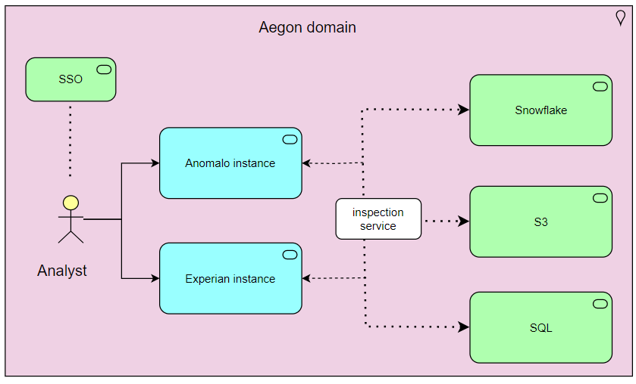

Technology Components & Architecture Impacts
List the technology components impacted by the change.

Technology Component Type | Technology Component Name | CMDB ID | Architecture Impact | Tech Lifecycle Strategy | Application Risk Rating
Business Application, Software, Hardware, Cloud Component | Application Name, Software Name, Hardware Name, Cloud Component Name | CMDB ID if in the CMDB  If not in the CMDB, indicate ‘New’  Prior to Project Solution - Final ARB, ‘New’ items must have a CMDB id to receive a passing score within the Architecture Alignment to Standards scorecard | Replace, Decom, Migrate, Re-use, Enhance, New | Buy, Hold, Sell  This is located in the Application IT Compliance Data in CMDB.  Search for the application an select the latest UPDATED date. The Application Lifecycle Strategy is on the right | Application Risk Rating is found by clicking on the link within the Application IT Compliance Data tab at the bottom of the application’s CMDB entry
Business Application | Anomalo | New | New | Buy
Business Application | Experian | New | New | Buy

Gap Analysis
N/A

Components

Components or Patterns Used
This will include the logical high-level architecture diagram based on the previous contextual diagram and a list of components used in the solution (use links when possible).
GTS Component Architecture Standards (sharepoint.com)
GTS Reference Architectures (sharepoint.com)
GTS Architectural Patterns (sharepoint.com)

Component Architecture Diagram



Components or Pattern Table
Components/Patterns Used |  | Link | Version
1 | AWS EC2
2 | Inspection service
3 | SSO
4
5
6

Integration Architecture

Integration Architecture Diagram
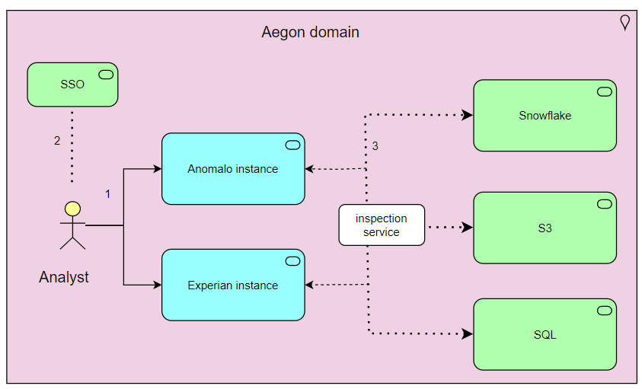

Integration Architecture Table
Connection | Source  Component | Target  Component | Purpose | Security Integration Pattern Name
1 | Analyst | Application instance | UI access | Inspection service
2 | Analyst | Ping SSO | Authentication | Ping SSO
3 | Data source | Application instance | Data scanning | Inspection service
4
5
6

Data Flow

Data Flow Diagram

Data Flow Table
Data Flow Reference |  | Description
1
2
3
4

Data Protection
There are no HA, DR requirements for the POC.
The default Backup/Recovery services are considered sufficient.

Authentication and Authorization

The applications do support SAML/SSO and RBAC within the application. Those will be validated.

Security Boundaries

User access will utilize default SSO patterns.
Data access and authentication will be explored, where appropriate a secrets manager will be used.


Security Boundaries Table
Security Boundary Reference |  | Existing Pattern | Description
1 |  | Inspection service | User access to application
2 |  | Ping SSO | User SSO authentication
3 |  | Inspection service | Data access from application to data sources
4
5
6

Data Solution

Data Classification

Data Confidentiality Classification |  | Data Legal and Regulatory Classification
☐ | Strictly Confidential | ☐ | Financial Information
☒ | Confidential | ☐ | Personal Identifiable Information
☒ | Internal | ☐ | Protected Health Information
☐ | Public | ☐ | Payment Card Information
☐ | No Data Shared | ☐ | No Personal Data Shared

Data Encryption
Data encryption to be verified; data traffic is taking place within domain boundaries.

Data Residency
Data resides within domain boundaries.

GenAI (Future v.3)
Text/Links/Checkboxes….
Aegon GenAI - Home (sharepoint.com)
Group Gen AI Policy v1.0.pdf

Service Model (Not Required)

Implementation Approach

Proposed level of coordination
The following activities will be carried out by the business requester:
- Completion of due diligence activities according to the CBSD Checklist and provision of evidence to GTS
- Implementation of (VPC) network configuration
- Deployment 2 EC2 server instances and associated storage
- Installation of vendor applications
- Configure connectivity to data sources
- Perform PoT
- Raise a Web Security Protection request for SSO to the third-party solution
- Environment Type - ‘AWS’
- Provide additional info to GTS on the third party’s SSO setup for review

Dependencies
Availability of data sources.

Licensing
Trial licenses are to be procured.
Licenses model differ per vendor.
For Anomalo the licenses costs are table based; the more tables and data are required the more costs are involved.
For Experian there is an all-inclusive set price.

Artifacts
Review Process and Acknowledgements
In Scope | Owner | Non-Architecture Review / Assessment Process | Point of Contact | Link to Acknowledgement or Evidence
☐ | Internal Compliance & Controls | Technology Risk Assessment (only for Core and Common designs) | Mark Scarloss | Link
☐ | GTS – Information Security | Information Security Review (process in development and will replace security review section) | Nick Russel, Chad Hunter, or Jeff Bain | Link
☐ | Data Privacy | Data Privacy Impact Assessment (OneTrust) | Adam Kaminski | DPIA Number

Waivers and/or Exceptions (Not Required)

Estimated Costs

Financial Considerations
For the PoT the expected costs involve:
- One time setup of EC2 instances
- Resourcing cost, estimated 16 hours per instance.
Application | Instance | OS | Cost 8h/day/month
Anomalo | 32CPU, 256GB, 100GB disk | Linux | 476$
Experian | 16CPU, 32GB, SSD | Linux | 150$

Non-Financial Considerations
TBD

Financial Assumptions
No or minimal licenses costs involved at this stage.

Resourcing Considerations
For the EC2 instances, the default server operations request can be used.
For the application installation configuration support will be required from the CT team.

Exit Strategy (Not Required)

Success Criteria for the POC

Requirements
The applications functions will be tested based on a feature requirements list: DQ Tool Capabilities - Rqmts (For Vendor Response).xlsx.
Furthermore the several connectors will be validated.

Alignment to Architecture Principles
Architecture Principles (sharepoint.com)
Architecture Principles Alignment |  | Justification for lack of alignment (or a comment)
☒ | Capability Driven
☒ | Data Excellence
☒ | Modern
☒ | Secure and Compliant
☒ | Transparent
☒ | Future Proof
☒ | Reliable
☒ | Interoperable
☒ | Standardized
☒ | Value Oriented

POC Outcomes / Findings

Components or Patterns
N/A

Data and Data Flows
No non-standard patterns use expected.

Observability
Default EC2 server patterns will be used, fitting the default established observability pattens.

Data Protection
No specific requirements.

Data Residency and Encryption
No specific concerns.

Authentication/Authorization
No non-standard patterns use expected.

Security Boundaries

Security Boundary Reference |  | Existing Pattern? | Description
1
2
3
4
5
6

Licensing and Cost
Text

Coordination Activities to be considered
Resources will need to be reserved for coordination, alignment with several stakeholders and implementation.

Exceptions
No non-standard patterns use expected.

Appendix A: Architecture Review Board Scorecard
<link to scorecard>

Appendix B: Related Documents
Links and other pertinent references

Appendix C: Glossary of Terms and Acronyms
Addendum: Success Criteria for the POC

